Data programming 19_3

SELECT last_name, department_name

FROM employees CROSS JOIN departments;

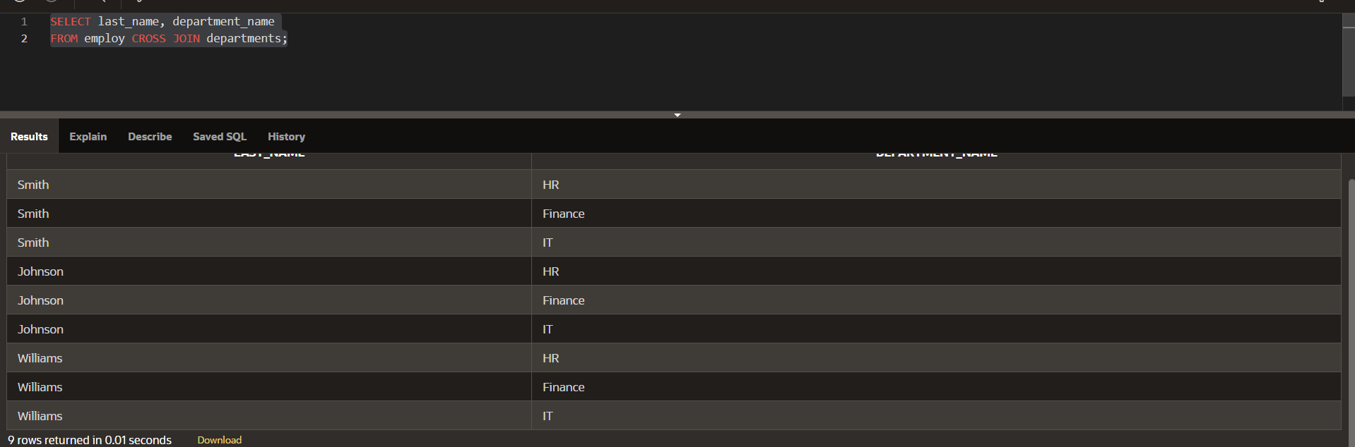

SELECT employee_id, last_name, department_name

FROM employees NATURAL JOIN departments;

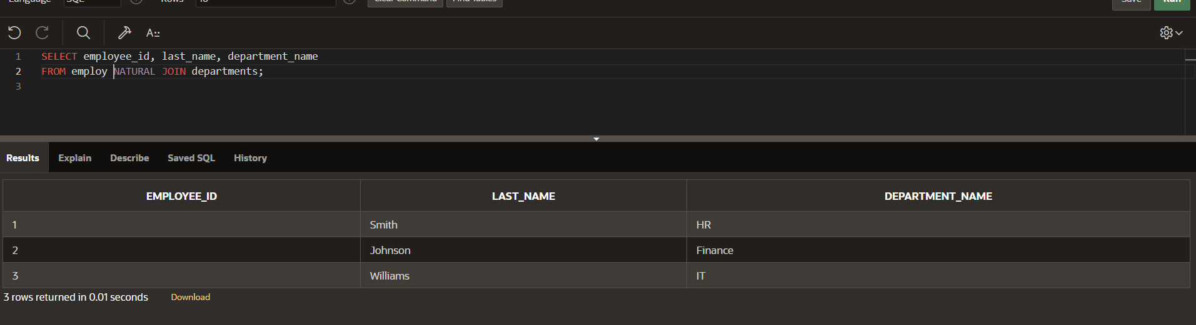

SELECT e.employee_id, e.last_name, e.salary, j.grade_level

FROM employ e JOIN job_grades j

ON (e.salary BETWEEN j.lowest_sal AND j.highest_sal);

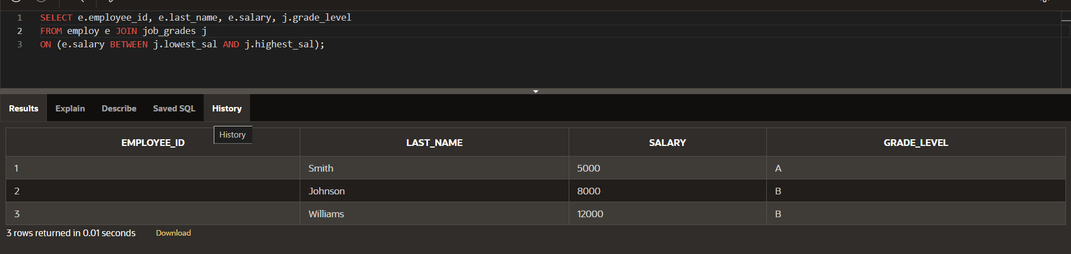

**SELECT employee_id, last_name, department_name**

**FROM employ JOIN departments**

**USING (department_id);**

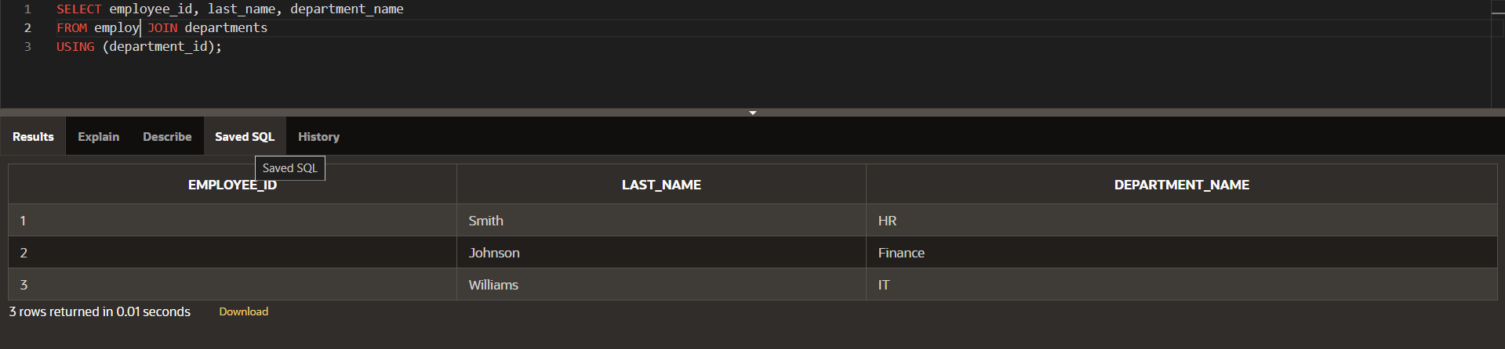

SELECT e.employee_id, e.last_name, d.department_id,

d.location_id

FROM employees e JOIN departments d

ON (e.department_id = d.department_id);

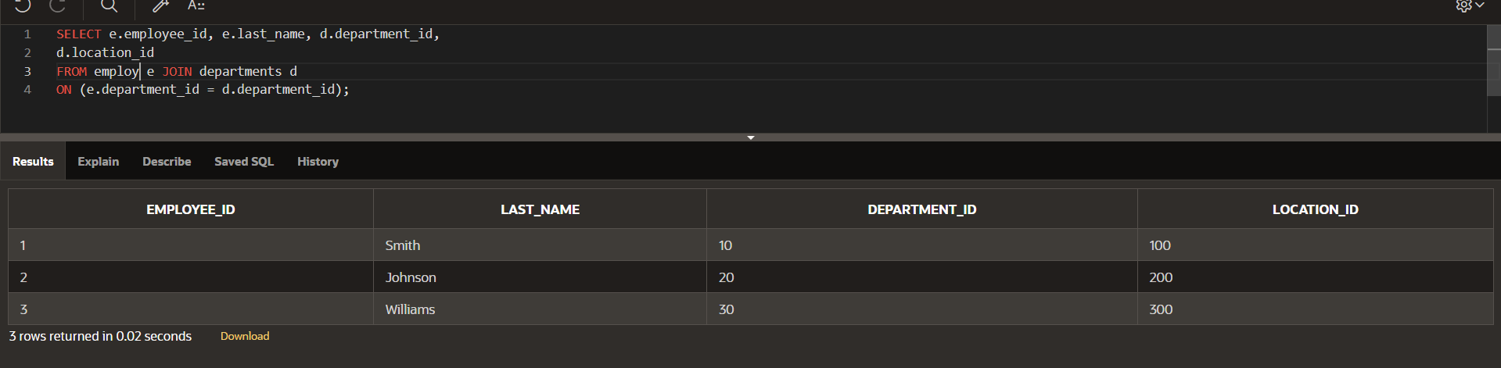

SELECT e.employee_id, e.last_name, e.department_id,

d.department_name

FROM employ e RIGHT OUTER JOIN departments d

ON (e.department_id = d.department_id);

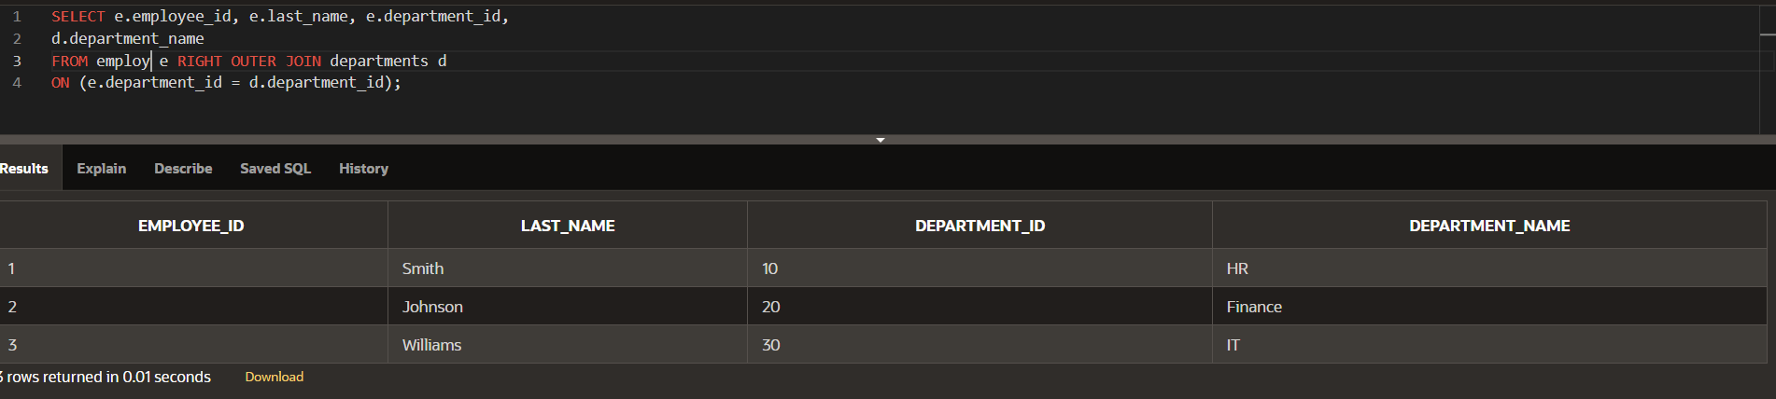

SELECT e.employee_id, e.last_name, e.department_id,

d.department_name

FROM employ e LEFT OUTER JOIN departments d

ON (e.department_id = d.department_id);

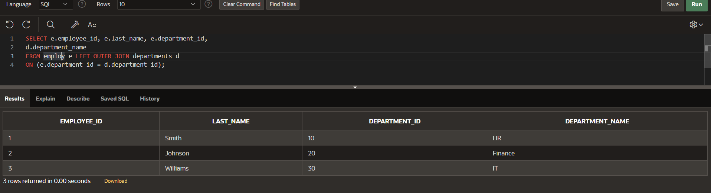

SELECT e.employee_id, e.last_name, e.department_id,

d.department_name

FROM employ e FULL OUTER JOIN departments d

ON (e.department_id = d.department_id);

